TMT/Rooftech Engineering/S0614/2025 19-12-2025

To,
Mr. Nurul
Company : Rooftech Engineering
Phone No :91+9113328750
Mobile No :+919113328750, 91+9113328750
Email : rooftech.bengal@gmail.com
City : '''Bolpur''', State : ''West Bengal'

Dear Sir,

SUB :- SUPPLY OF 100 TONS H frame HYDRAULIC PRESS

With reference to our discussions regarding your requirement for press. we are glad to inform you that, we are in a position to supply you the required equipment. The following are the specifications and our terms and conditions.

Specifications of the equipment

Technical Specifications :-

Pressing cylinder

❖ Max Working Pressure - 200 Kg/cm2
❖ Normal Working Pressure - 160 Kg/cm2
❖ Design Pressure - 250 Kg/Cm2
❖ Tonnage at 100 Kg/cm2 - 100 Tons
❖ Cyl Bore - 250 mm
❖ Rod Dia - 140 mm
❖ Stroke - 300 mm
❖ Mtg - Front Flange
❖ Approach Speed - 35 mm/sec
❖ Pressing Speed - 0-5 mm/sec
❖ Return Speed - 44 mm/sec
❖ HP - 20 HP
❖ Tank Cap - 450 Ltr

Detail Bill of Material

❖ Cylinder Seals - Imported German Seals ( Merkel or Halite )
❖ Motor - ABB / Siemens / Kirloskar / Crompton
❖ Rod Seal - Imported halite Seal
❖ Valves - Yuken / Polyhydron / Hydrotech
❖ Check Valves - Polyhydron
❖ Hydraulic Pump - Yuken / Dowty
❖ High Pr Pump - Polyhydron
❖ Bell Housing - Micro
❖ Relief Valves - Polyhydron
❖ Hyd Tank - Micro
❖ Hyd Tank - MHPL
❖ Fitting - Hyloc / Hydair
❖ Gasket - Champion
❖ Fastners - TVS / LPS

S No | Description of the unit | Offer
1. | H Frame 100 Ton hydraulic press with stroke 300 mm and daylight 600 mm along with electrical panel and power pack.  Along with | Rs 3,20,000/- (Rupees Thress lakhs Twenty thousand only)

GENERAL TERMS & CONDITIONS:

1 Price quoted per unit ex-work. Hyderabad.
2 Following charges are additional to your account.
- Freight Charge : As actual to be borne by you.
- Excise : 12.50%
- Sales Tax : 5% Vat.
- Packing charge : As actual to be borne by you.
- Insurance : As actual to be borne by you.
3 Payment : 50% advance alongwith order another 25%
advance after 3 weeks from first advance and
balance before delivery but after inspection at our
works.
- Delivery : 5-6 weeks from date of techno-commercially clear
purchase order.
- Validity : One month from the date of submission.
- Inspection : Inspection at our works prior to dispatch.
- Warranty : The machine is warranted for a period of 12
months from the date of dispatch against any
manufacturing defects/faulty material or bad
workmanship of any part or component but not
against any kind of abnormal or improper use of
machine. Defective part or component will be
replaced or repaired free of cost. Electrical
components are outside the scope of this
warranty.
- Commissioning : Erection & commissioning done by you, but if
required technical support & guidance provide by
us at additional cost.

NOTE:
- Oil is not in scope of our supply.
- Raw material for trial is to be arranged by you at your cost.

We are sure you will find our offer in line with your requirements. Should you require any further clarification please contact 9246221106

Thanking you and assuring you of our best services.
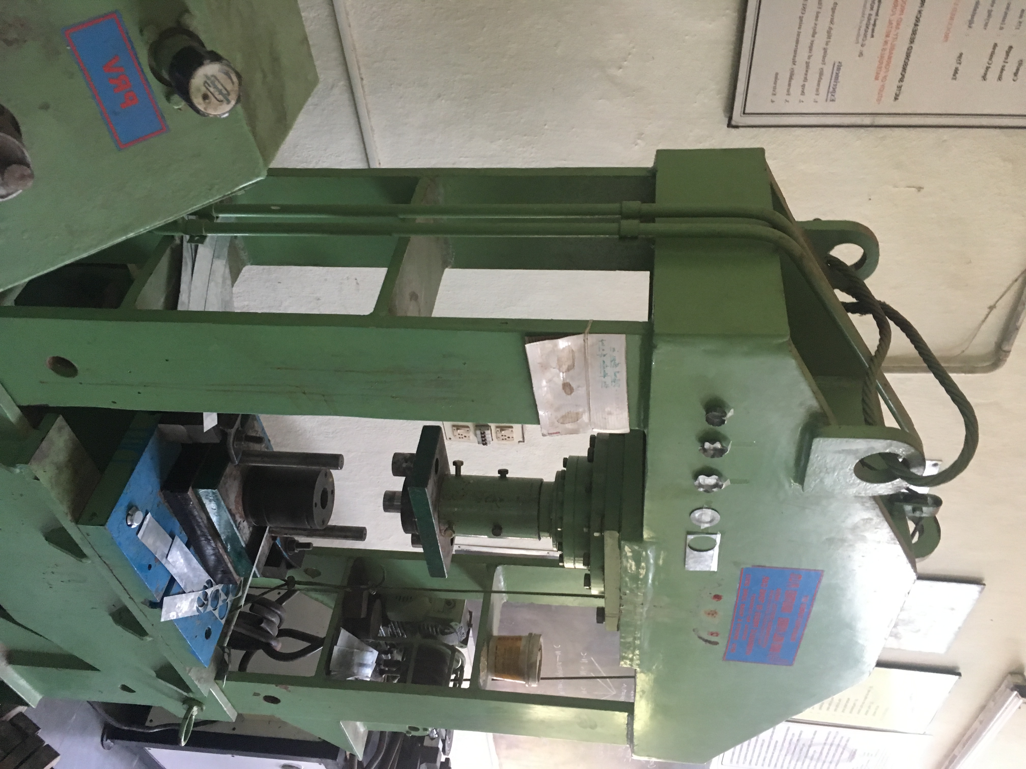

For TECHNO MACHINE TOOLS

(T. SIVARAMAKRISHNA)

